“ATHLETES ALTERING DESTINIES”

YES, COUNT ON OUR SUPPORT!

Company Name________________________________________________________________

Contact_______________________________________________________________________

Email Address_________________________________________________________________

Mailing Address _______________________________________________________________

Phone________________________________________________________________________
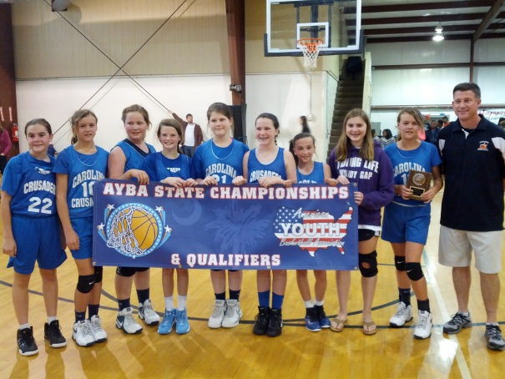
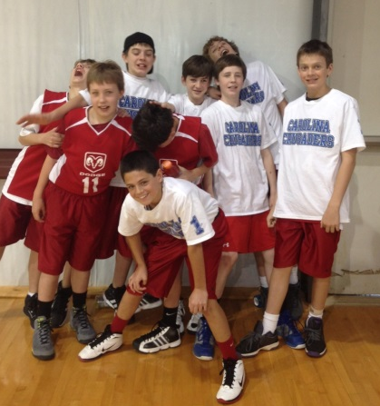
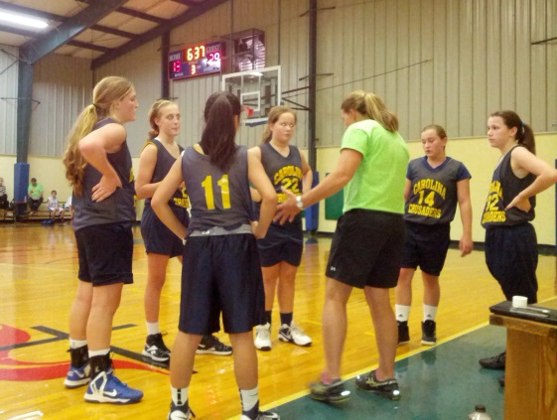
Checks can be made payable to Dribble for Destiny, Inc. and mailed to 212 Ridge Point Road, Easley, SC 29640.
Phone: 864-525-1433 ● info@dribble4destiny.org ● www.dribble4destiny.org
Federal ID #57-1106598
PLEASE INCLUDE A COPY OF YOUR BUSINESS LOGO FOR ADVERTISING ON OUR WEBSITE AND OTHER PUBLICATIONS.

_______________________________________________ ____________________________
Signature of Sponsoring Company Representative Date

_______________________________________________ ____________________________
Signature of Dribble for Destiny Representative Date

Sponsorship Level

Gold Sponsor - $10,000
Bronze Sponsor - $7,500
Silver Sponsor - $5,000
Blue Sponsor - $1, 000
Red Sponsor - $750
White Sponsor - $500

